**DHONI IN IPL2020**

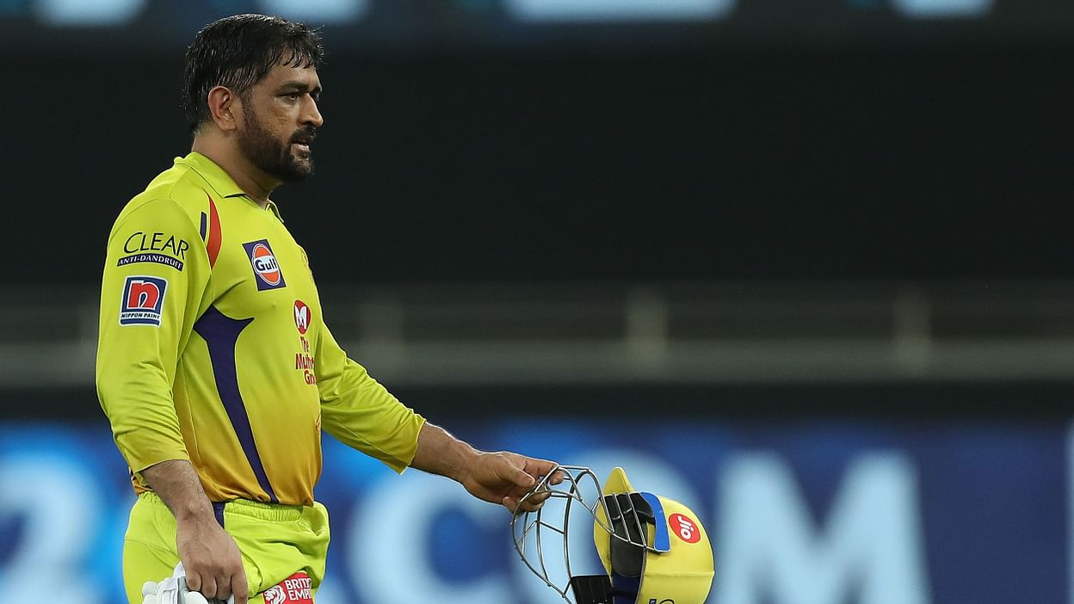

**Installed libraries**

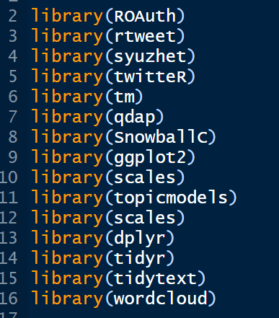

**Creating Api tokens and secret keys**

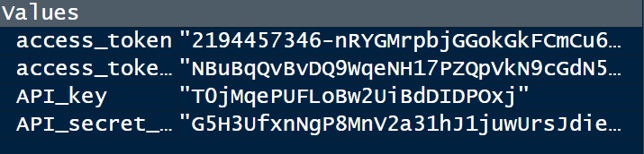

**Extracting data from the #farmerbill and converting into dataframe**

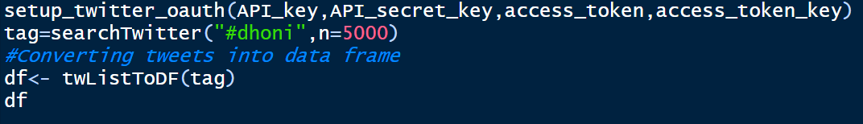

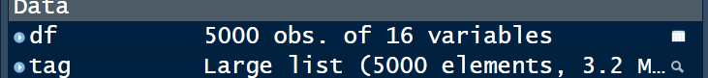

**CREATING CSV FILE**

**LOADED FILE INTO CORPUS**

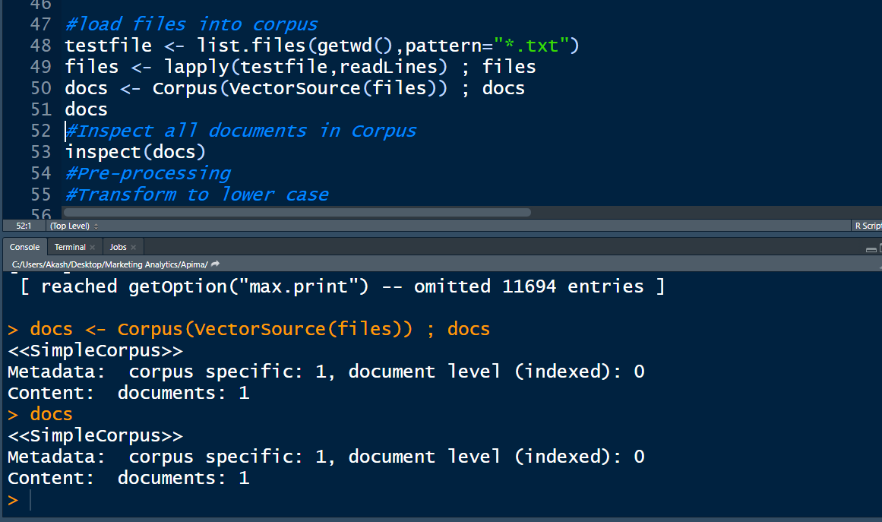

**AFTER PREPROCESSING, INSPECTED DOCUMENT**

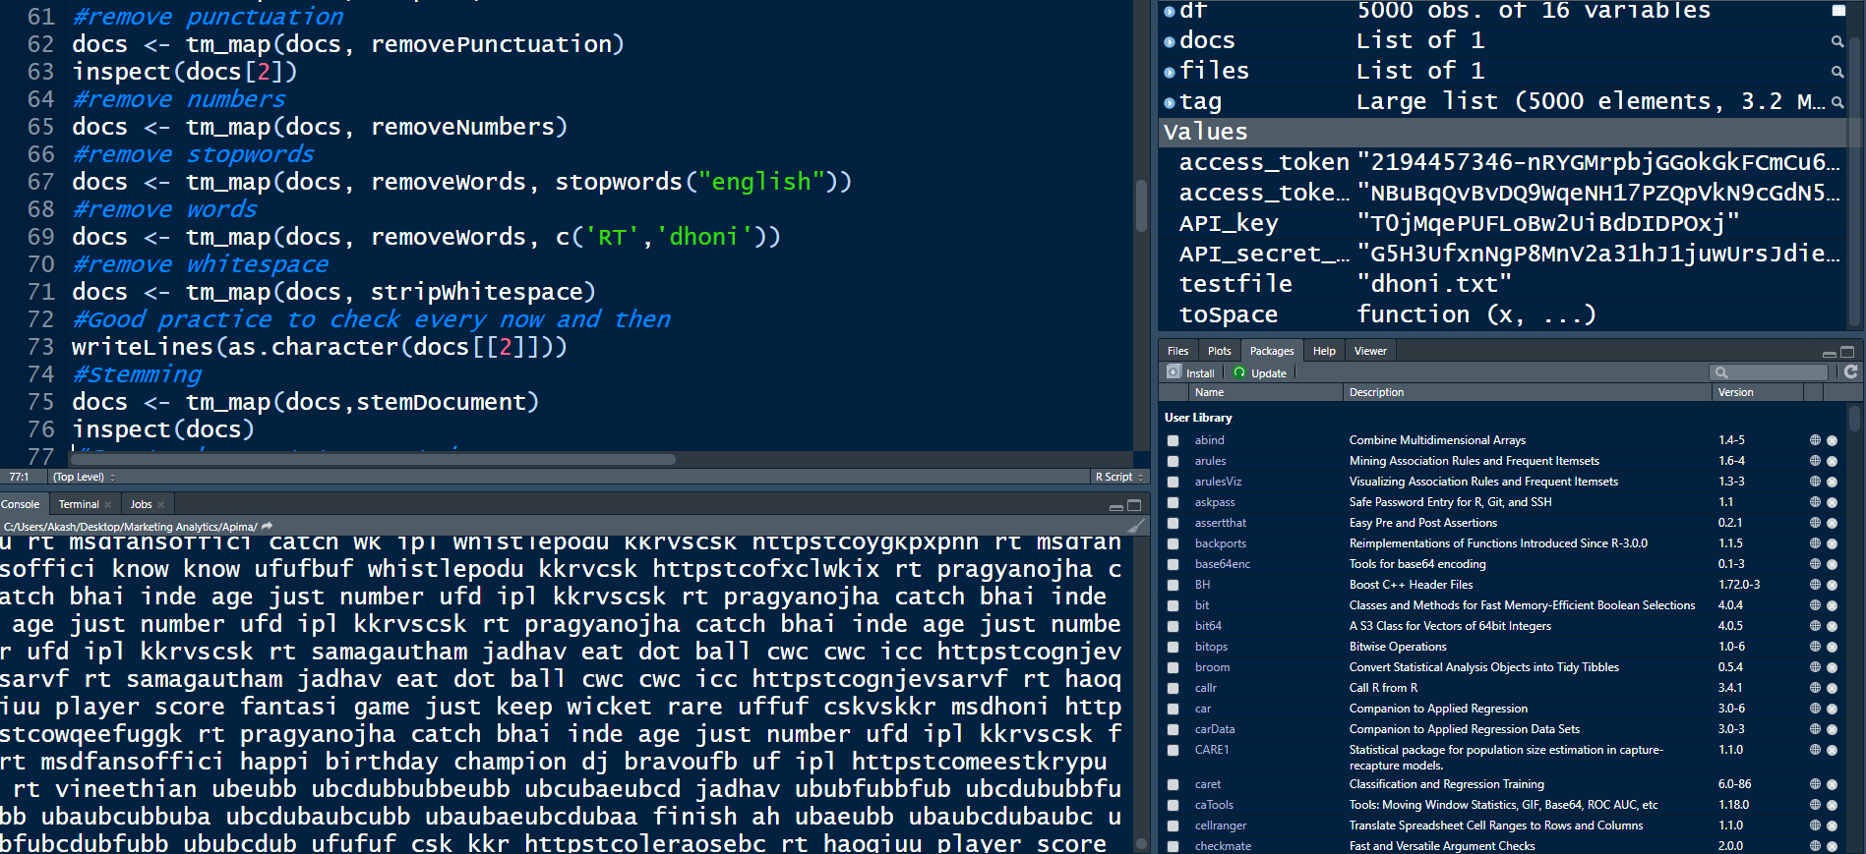

**FREQUENCY OF WORDS IN CORPUS**

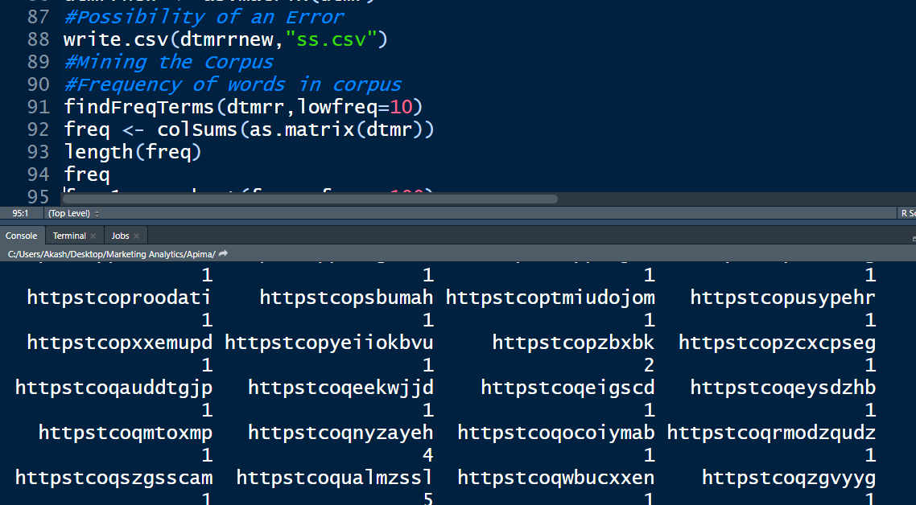

**SORTING TOP TERMS ACCORDING TO FREQUENCY**

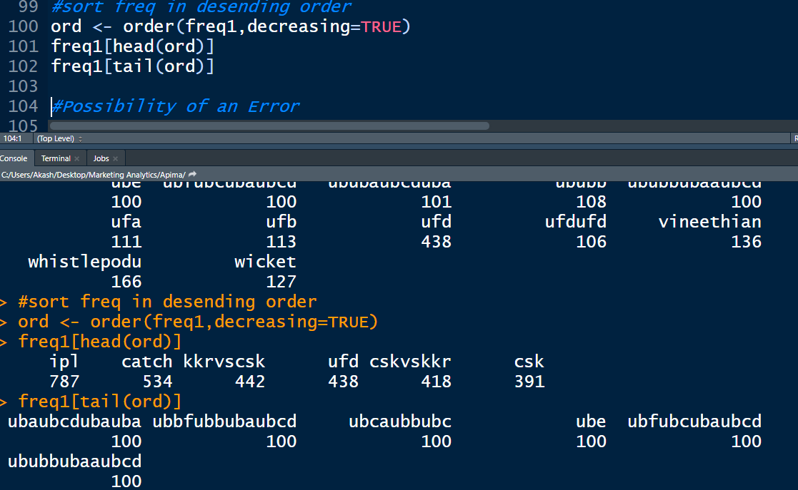

**PLOTTING BARCHART WITH MOST FREQUENT WORDS**

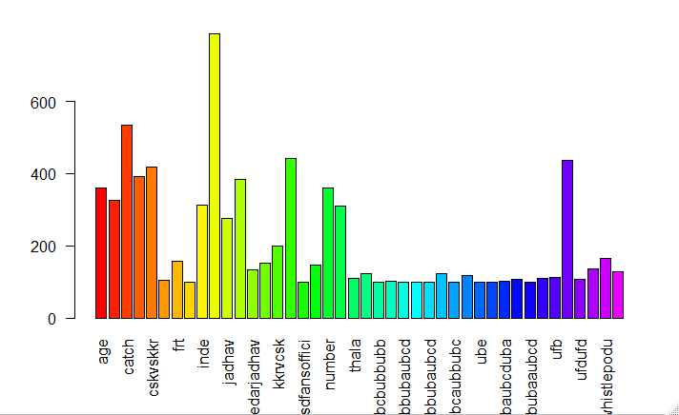

**WORD CLOUD**

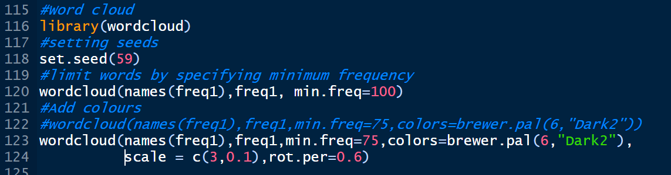

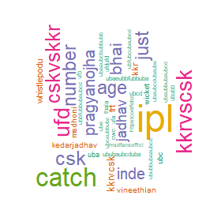

**SENTIMENT ANALYSIS**

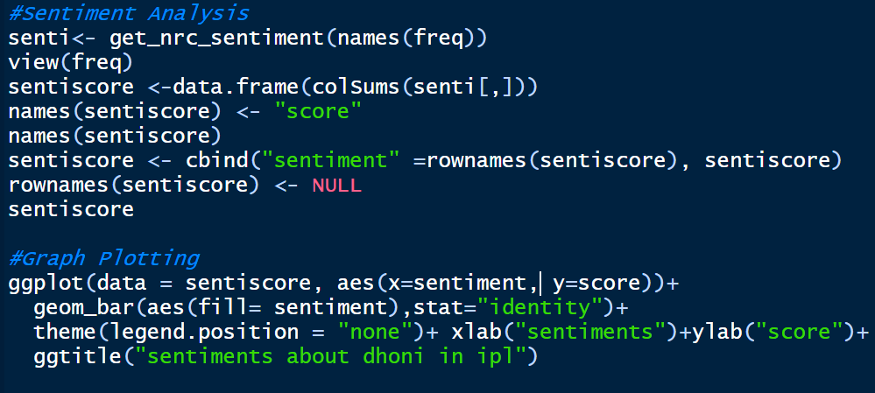

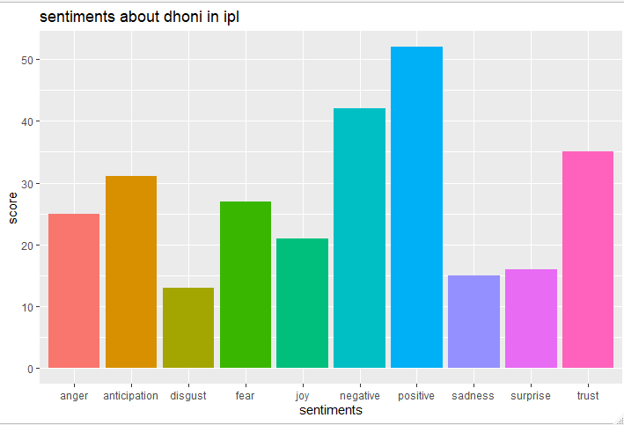

**INTEPRETATION**

* After seeing sentiment analysis graph, we can interpret that majority of people are having positive emotion towards Dhoni, despite his poor performance in recent times.
* Apart from negative emotions, we can also see anticipation and trust, which are key factors indicates people are still believing in dhoni.
* In word cloud, we can see Age, catch, are most talked words about dhoni and also, we can view Jadhav name occurred most times, which actually predicted one, since he single handedly lost match for CSK.